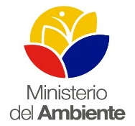
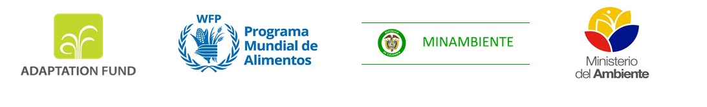

Building adaptive capacity to climate change through food security and nutrition actions in vulnerable Afro and Indigenous communities in the Colombia-Ecuador border area

Inception Report

MAY 2018

Table of Contents

1. Introduction 4
1.1 Background to the project 4
1.2 Project Objectives 5
1.3 Project Components 5
2. Actions to date 6
3. Inception workshop 8
3.1 Objectives 8
3.2 Agenda 8
3.3 Conclusions of the inception workshop 10
4. Key Decisions and Outputs 11
4.1 Project Governance Structure 11
4.2 First year implementation plan 14
4.3 Monitoring and evaluation 16
4.4 Procurement 16
5. Key Challenges 17
6. General conclusions 19
7. Annexes 19

List of Acronyms

AbC: Communities-based adaptation to climate change
EbA: Ecosystems based adaptation
CANE: Afro-Ecuadorian Confederation of the North of Esmeraldas
CB: Binational Coordinator
CGB: Binational Management Committee
CNC: National Coordinator of Colombia
CNE: National Coordinator of Ecuador
CORPONARIÑO: Local environmental corporation (Colombia)
CTAN: National Technical Advisory Committee
EMI: Multilateral Implementing Entity
ENSO: El Niño-Southern Oscillation
COMBIFRON: Binational Commission Colombia Ecuador
AF: Adaptation Fund
FORECSA: Adaptation Fund project “Enhancing resilience of communities to the adverse effects of climate change on food security, in Pichincha Province and the Jubones River Basin”
GADS: Decentralized autonomous governments
GFA: Gran Familia AWÁ
IDEAM: Institute of hydrology, meteorology and environmental studies (Colombia)
ITCZ: Inter-Tropical Convergence zone
INHAMI: National Institute for Meteorology and Hydrology (Ecuador)
NGO: Non-Governmental Organization
MADS: Ministry of Environment and Sustainable Development of Colombia
MASL: Meters above sea level
MAE: Ministry of Environment of Ecuador
MAG: Ministry of Agriculture of Ecuador
RECOMPAS: Community Council Network of the South Pacific
SENAGUA: National Secretary on water resources management (Ecuador)
UNDP: United Nations Development Programme
UNFCCC: United Nations Framework Convention on Climate Change
WFP: World Food Programme

Introduction

1.1 Background to the project

Colombia and Ecuador are two of the countries in South America with the highest exposure to climate impacts. The border area between these two countries is also one of the most food insecure areas in the continent. These factors have been exacerbated by the Intertropical Convergence Zone (ITCZ) in the area, meteorological and geographical conditions related to solar radiation, extreme wind and precipitation, as well as recurrent effects from El Niño- Southern Oscillation (ENSO). Additionally, the armed conflict in Colombia has severely affected and destabilized both sides of the border, through violent events against social leaders and local population, forced displacement, environmental damage, limited access to productive assets and land, as well as through reduced access and provision of social services.

The project targets two watersheds: Mira-Mataje and Guaitara-Carchi. The targeted watersheds range in altitudes from zero to 1,800 meters above sea level (MASL), and in temperatures between 8 and 24 degrees Celsius. These climatic conditions have facilitated the growth of different ecosystems, such as tropical rainforests, moorlands, mangrove forests, among others. Rainfall patterns are bi-modal, with two peak rainy seasons occurring from March to June and from November to January, with a dry period from July to August. According to climate scenarios generated by the Institute of hydrology, meteorology and environmental studies (IDEAM) for Colombia, temperatures will increase by up to 2.6°C in the border region by 2100. Similarly, RCP 4.5 climate scenario for 2100 predicts temperature increases by up to 1.5°C in the Esmeraldas and Carchi communities. It is also important to note that women in local communities are more vulnerable to climate change than men, given their lower education levels, lower access to credit, lower participation in decision-making processes and lack of access to relief services. Women also lack compensation of property losses due to their lack of property titles.

The area is also affected by extreme weather events, including floods, landslides, droughts and tsunamis, exacerbated by changes in climate, meteorological conditions and land occupation. Ecosystems in the targeted watersheds, as well as the livelihoods and food security of local Awá and Afro communities are negatively impacted by climate change and climate variability. Loss of mangrove forests due to rising sea levels, intensification in rainfall patterns and sedimentation reduce production of estuarine species such as shellfish, red crab and sea bass for trade and consumption in these communities. Extreme climate events are also affecting the cultivation of plantains and cacao staple foods and cash crops for the Afro communities in the region. Similarly, the changing composition in ecosystems due to increasing temperatures has reduced diet diversity of Awá communities while decreasing crop yields of Afro communities in the border area. Afro and Awá populations also face high levels of malnutrition and insufficient food consumption.

1.2 Project Objectives

This project was designed as a joint effort between the Ministry of Environment of Ecuador (MAE), the Ministry of Environment and Sustainable Development of Colombia (MADS), community-based organizations and community leaders of Awá and Afro communities. Project formulation started in 2015 and ended in 2017 with the approval of the project proposal by the Adaptation Fund Board. Different stakeholders from local governments, private sector, NGOs and academic institutions participated in different consultations in Colombia and Ecuador to guarantee the incorporation of best practices and lessons learned on adaptation to climate change and food security and nutrition as well as to ensure the involvement of different actors.

The binational project aims to contribute to the capacity strengthening of vulnerable women and men in climate change adaptation and to promote food security and nutrition of Awá and Afro communities in two watersheds on the Colombia-Ecuador border area. The project is aligned with binational working groups, national policies and communities’ priorities, while also incorporating a gender and intercultural approach.
In particular, the project aims to:

- Reduce climate vulnerabilities of Afro and Awa communities and the ecosystems they depend on, promoting food security, nutrition, gender equality while also contributing to the construction of peace.
- Strengthen adaptive capacities of regional institutions and Afro and Awa communities in the border area.

1.3 Project Components

In support of international, binational and national policy frameworks, as well as communities’ priorities, the project will adopt a culturally and gender-sensitive territorial approach, through community-based adaptation (CBA) and ecosystem-based adaptation (EBA) approaches. All the actions will address adaptation to climate change, climate variability and promote food security and nutrition through the following three main components.
Component 1: Increase community awareness and knowledge on climate change risks, food security and nutrition in the binational watersheds.
This component will raise awareness and increase knowledge of climate risks and adaptation solutions, with special attention to the integration of ancestral knowledge and food security and nutrition. Traditional and local knowledge will be compiled through a portfolio of studies on native species and their potential to: increase resilience to climate change, improve diet diversity, and add market value to locally made products, contributing to improved income generation and access to markets. Finally, cultural spaces and community events will be promoted to foster inter-generational dialogue and learning, and communities exchange on traditional knowledge and practices.

Component 2: Increase binational, institutional and community capacities to sustainably address recurrent climate risks, particularly those that affect food security and nutrition
All activities will integrate traditional and scientific knowledge to increase understanding of climate change threats and potential adaptation solutions through the development and implementation of culturally competent, gender-sensitive early warning systems, and the provision of climate change services in target communities. This will occur in collaboration and coordination with The National Institute for Meteorology and Hydrology (INHAMI) of Ecuador, its Colombian counterpart IDEAM, Colombian-Ecuadorian local organizations and stakeholders. These actions will be complemented with training of regional communities’ leaders and government officials on emergency preparedness to natural disasters. These activities will promote the integration of climate change adaptation and disaster risk management into territorial planning.
Component 3: Reduce recurrent climate vulnerabilities through innovative community and ecosystem-driven adaptation measures that reduce food insecurity.
This component will support community identification and implementation of concrete adaptation measures, which will help to respond to climate threats identified in ‘Component 2’ and link scientific, traditional and local knowledge of Awá and Afro populations. All activities will be included in the aforementioned community-based adaptation plans. These activities will be carried out with equal participation of youth, women, men and elders living in the target communities.

Actions to date

This section describes the activities undertaken to date to build consensus and awareness on project goals and objectives, project implementation and to ensure that project activities are aligned with binational and national policies and the target communities’ priorities. An understanding of the project goals and objectives among key stakeholders is essential to ensure effective project implementation as well as to integrate effective measures into adaptive planning strategies.

The project proposal and pre-inception process required significant political and technical support from national and local institutions and organizations. The pre-inception process included different meetings and workshops to involve local actors and reach a common consensus on the priorities related to climate change adaptation, food security and nutrition, as well as to ensure participation among members of the Awá and Afro communities.

- Project proposal design process: In 2016, WFP hired a team of consultants to finalize the project proposal and support project design activities. The consultant team coordinated activities with WFP Colombia and WFP Ecuador, and worked in close coordination with MADS in Colombia and MAE in Ecuador to ensure that the project proposal would be aligned with national climate policies, strategies and goals.
- Consultative process with communities: As part of the project proposal design process, WFP organized and carried out a series of binational meetings in Colombia and Ecuador in 2016 with local communities to better understand their perceptions of climate threats, their perceived vulnerabilities and possible opportunities to engage with WFP in adaptation activities. WFP conducted local workshops among communities to socialize and discuss project management structure, proposed adaptation measures and climatic threats identified in previous meetings.

- Coordination with national and local authorities: For the project proposal, WFP worked in close coordination with MADS and MAE in alignment with binational and regional policies related to climate change adaptation, food security and nutrition, sustainable development and peace building among marginalized communities. WFP held two bi-national meetings with government counterparts to share views on the concept, and jointly identify priorities for the development of the concept note. This process was conducted during 2016, which included a series of bi-weekly and monthly meetings with stakeholders at national, departmental and community levels. In addition, WFP sub-offices held meetings with other relevant actors including NGOs and UN Agencies to discuss ongoing activities and experiences relevant to the project strategy. After the approval of the concept note, WFP has continued to engage in a full range of consultations to include increased focus at the community level. This has enabled a detailed understanding of priorities, capacities and activity plans.

- Endorsement letter: At the beginning of April 2017 WFP, MADS and MAE signed the final endorsement letter, providing full support to implement the project.

- Approval of project proposal: In mid July 2017, the Adaptation Fund Board approved the project proposal presented by WFP.

- Preparation meetings for Inception Workshop: After project approval, WFP Colombia and WFP Ecuador held four meetings with MADS and MAE to define next steps for project start:
- September 11th, 2017: Initial binational meeting after project approval.
- November 15th, 2017: Experience exchange based on the implementation of the Adaptation Fund project “Enhancing resilience of communities to the adverse effects of climate change on food security, in Pichincha Province and the Jubones river basin” (FORECCSA) in Ecuador. Discussion about targeting, funds allocation between countries and terms of reference of the project coordination team.
- February 14th, 2018: Preparation of Inception Workshop agenda. Discussion of the governance structure.
- March 13th, 2018: Discussion of first draft of year one Binational Implementation Plan and project Operational Manual. Introduction of the project coordination team.

- First meeting of the Binational Management Committee: Delegates from WFP Colombia, WFP Ecuador, MADS and MAE held the first Binational Management Committee meeting on May 2, 2018. Final outcomes of the meeting included: i) Presentation and discussion of the project’s governance structure; ii) Approval of the Inception Workshop agenda; iii) Discussion of the project’s operational manual; iv) Setting the rules and membership of the Binational Management Committee (see Annex 1 for agenda and conclusions).

- Inception Workshop: In order to initiate the project, WFP Colombia and WFP Ecuador joined efforts with MADS and MAE to organize the Inception Workshop with project stakeholders, NGOs and local community members. The Inception Workshop took place in Ibarra, Ecuador on 3-4 May 2018.

Inception workshop

3.1 Objectives

- Communicate the scope and goals of the binational project to key stakeholders and community leaders.
- Discuss and approve the project’s governance structure.
- Identify key issues related to project implementation and stakeholders’ and communities’ roles and responsibilities, in order to ensure coordination and communication strategies among project partners.
- Agree on the first year’s implementation plan

3.2 Agenda

The Inception Workshop was held in the Hotel AJAVI, located in Ibarra, Ecuador. The Inception Workshop agenda covered key issues regarding project implementation, roles of main stakeholders, project governance structure, scope and objectives, monitoring and evaluation plans, gender mainstreaming and community based participatory methodologies. (See detailed agenda attached in Annex 2).

First day (Thursday, May 3, 2018)
Workshop First day (May 3, 2018)
Issues addressed | Results
Project overview: objectives and main components | Project objectives and main components were shared with participants. Mainstreaming of community-based approach (CBA), ecosystem-based approach (EBA) and gender will direct project implementation. Workshop participants agreed with project goals, objectives and main activities.
Project governance structure | Project governance was discussed. Community’ leaders suggested that project implementation required an active participation of local communities in the decision-making process at all levels.
Activities to be executed during year one | The project roadmap for year one, with general components and main activities, was developed with participants.
Project strategy at binational, national and local level | Validation of project strategy and priorities at binational, national and local level, and confirmation of commitment from Awá and Afro community leaders.
Involvement of local actors and project roadmap | To ensure successful implementation at local level, the project will work directly with the communities in the targeted watersheds through participatory processes, in collaboration with local institutions, NGOs and other stakeholders.

Table 1: Issues addressed during first day

Second day (Friday, May 4, 2018)
Workshop Second day (May 4, 2018)
Issues addressed | Results
Gender mainstreaming | Participants highlighted the importance of gender mainstreaming in the project, with respect to Awá and Afro cultures, lifestyle, vision of the world, as well as varying beliefs and traditions.
Approval of governance structure | Approval of the governance structure, which included the involvement of community leaders in the decision-making process at all levels. In order to address bi-national issues with stakeholders as well as with Awá and Afro organizations, a bi-national coordination bureau has been created.
Communities participation in adaptation to climate change planning | Community participation was defined as a key element for project implementation. Using a participatory approach, available information and ongoing projects in the two watersheds will be identified in order to avoid duplication of activities.
Approval of project start | Workshop participants, including the main stakeholders and leaders of Awa and Afro communities, endorsed project start and signed a formal agreement.

Table 2: Issues addressed during second day

3.3 Conclusions of the inception workshop

- Workshop participants recognized the importance of designing a gender strategy for the project, which will contribute to address gender inequality and improve women’s participation in decision-making processes and their control of natural resources and assets.

- The capacity strengthening of community-based organizations to adequately address socio-economic and environmental risks associated with climate variability and change was identified as a priority by the representatives of both the Awá and Afro communities as key for the survival of their current lifestyle and cosmovision.

- Community leaders stated that protection of vulnerable people, promotion of food security and nutrition are key components to improve the well-being of communities, especially those affected by conflict among armed groups and illicit crops.

- Workshop participants approved project governance structure and communities’ involvement in decision-making processes is guaranteed at all levels.

- Workshop participants, including, the main stakeholders and leaders of Awa and Afro communities endorsed the projects commencement and signed a formal agreement.

Key Decisions and Outputs

4.1 Project Governance Structure

The project governance structure describes roles and responsibilities of all the actors involved in the decision-making process to ensure an effective implementation of the project. This project will be governed by a consolidated structure (see figure 1 below and Annex 3), which has been agreed among community leaders, national and local governments and the Multilateral Implementing Entity.

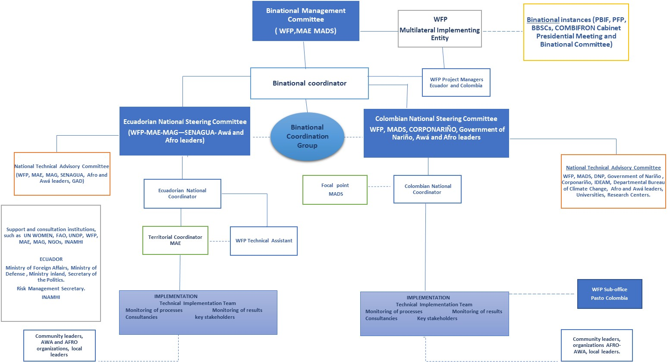

Figure 1: Project governance structure

The agreed roles of the main institutions are described in the following paragraphs.
Multilateral Implementing Entity (MIE):
WFP acts as the MIE. The MIE bears full responsibility for the overall management of projects and programs financed by the Adaptation Fund (AF). The WFP Country Directors play the role of trust fund managers. MIE oversees, and is accountable for all financial management, monitoring and evaluation of the implementation of activities to the AF. WFP also will guarantee that national strategies on food security and nutrition, adaptation to climate change and gender mainstreaming are incorporated in all project activities.
Ministry of Environment and Sustainable Development of Colombia (MADS):
MADS acts as the national authority in charge of climate change policies in Colombia and designated authority for Colombia to the Adaptation Fund. Its main role is to provide technical support and guidance to the project, and to ensure that all measures implemented are aligned and relevant to national and local priorities.

Ministry of Environment of Ecuador (MAE):
As the Ecuadorian national authority in charge of climate change and environment issues and as the designated authority for Ecuador to the Adaptation Fund, MAE will provide technical support and guidance, and coordinate with local entities to ensure that all activities are aligned with national priorities. MAE will also facilitate project implementation, contribute to the development of adaptation plans at the territorial level and raise awareness about climate risks at community level.

Binational Management Committee:
The Binational Management Committee (BMC) will be composed of delegates of the (MADS), (MAE), WFP Colombia Country Office and WFP Ecuador Country Office. Each will be supported by a technical advisor and by the Binational Coordinator, who in addition will act as secretary of the BMC.

The BMC is responsible for the supervision of all project activities, including the discussion and approval of annual work plans, budgets and reports to the AF. In addition, it will provide guidance for the operational implementation of the project and support the implementation of a communication and visibility strategy. It will carry out analysis of the project context in terms of security, as well as approve the procedures for monitoring and evaluation according to the rules and guidelines of WFP and AF. This committee will meet at least twice a year, through in-person or virtual meetings. However, any of its members may request an extraordinary meeting when the situation warrants it. In this case, the Secretary will inform all the members at least three weeks in advance of the scheduled meeting.

Binational Coordination Group:
Its main function is to address binational issues with key stakeholders and Awá and Afro communities and to ensure their participation in the decision-making processes. The binational coordination bureau is comprised of delegates from WFP, MAE, MADS and delegates of the Afro and Awá community-based organizations. In particular, it will discuss adaptation plans with binational coverage and foster the promotion of the project strategic components (food security and nutrition, gender mainstreaming, inter-culture) as well as review binational agreements for the effective implementation of the project.

The Binational Coordinator:
The coordinator will be responsible for project implementation oversight and management, and ensuring the adherence to AF rules and guidelines; preparing and coordinating the implementation of annual work plans and budgets, as well as the TORs for binational consultancies and studies, and supervising the daily work of the project team. In addition, the Binational Coordinator will also be responsible for monitoring and evaluation and facilitating communication and cooperation at the binational level. The coordinator will be in charge of presenting project progress to the binational management committee in order to assure that its recommendations are incorporated. He will report to WFP Country Offices in Colombia and Ecuador and to Binational Management Committee for project technical and financial implementation.

At national level, the National Steering Committees and National Technical Advisory Committees will support further project implementation.

National Steering Committees:
The National Steering Committees (NSC) in Colombia and Ecuador will be comprised of delegates from WFP, MADS and MAE, Ministry of Agriculture of Ecuador (MAG), other governmental institutions and legitimate representatives of Awá and Afro communities. Decisions will be subject to the recommendations of the National Technical Advisory Committee (NTAC) and they will be taken by consensus. The NSC is in charge of approving and monitoring the implementation of national annual operational plan and budget, in accordance with the National Technical Advisory Committee’s recommendations and in alignment with national frameworks and AF rules and guidelines. It will approve adaptations plans and adaptive measures aligned with climate change national policies and communities’ needs and priorities. It will monitor project implementation at national level, revise reports, approve monitoring procedures and ensure the mainstreaming of strategic issues (food security and nutrition, gender, inter-culture, adaptation based on communities and ecosystems). The National Steering Committees will meet at least twice a year, through in-person or virtual meetings. However, any of its members may request an extraordinary meeting when the situation warrants it. In this case, the Secretary will inform all the members at least three weeks in advance of the scheduled meeting.

National Coordinators of Colombia and Ecuador:
The National Coordinators will be in charge of project implementation and funds accountability, ensuring coordination and participation of Awá and Afro leaders and communities as well as key stakeholders. They are also responsible for the participatory design and implementation of community adaptation plans and will support the Binational Coordinator in monitoring and evaluation, while ensuring adequate documentation of lessons learned and best practices. The National Coordinators report to the Binational Coordinator and to WFP Country Offices.

Ecuadorian National Technical Advisory Committee:
The Ecuadorian National Technical Advisory Committee is composed of delegates of MAE, MAG, WFP, National Secretary on water resources management in Ecuador (SENAGUA), decentralized autonomous governments (GAD) and of Afro and Awá communities. Depending on the agenda, other members may be invited to provide technical assistance on specific issues. The National Coordinator will act as secretary of the committee. This committee provides technical recommendations to the National Steering Committee on project implementation and supports coordination among all actors involved in the project. In addition, the committee facilitates the exchange of information and communication at the national and local levels. This committee will meet at least twice a year, through in-person or virtual meetings. However, any of its members may request an extraordinary meeting when the situation warrants it. In this case, the Secretary will inform all the members at least three weeks in advance of the scheduled meeting.

Colombian National Technical Advisory Committee:
The Colombian National Technical Advisory Committee is comprised of delegates from MADS, WFP Colombia, Colombian National Department of Planning, local government of Nariño, local environmental corporation Corponariño, IDEAM, Departmental Climate Change Office and Awá and Afro communities. Depending on the agenda, other members may be invited to provide technical assistance on specific issues. The National Coordinator will be act as secretary of the committee. This committee provides technical recommendations to the National Steering Committee on project implementation and supports coordination among all actors involved. In addition, it facilitates the exchange of information and communication at national and local levels. This committee will meet at least twice a year, through in-person or virtual meetings. However, any of its members may request an extraordinary meeting when the situation warrants it. In this case, the Secretary will inform all the members at least three weeks in advance of the scheduled meeting.

Partners for project implementation at local level:
The project will be implemented through an inclusive process with a range of different partners. Gran Familia Awá, Community council network of the Southern Pacific area (RECOMPAS), Alto Mira-Frontera y Bajo Mira community councils, as executing entities, will support the elaboration of adaptation plans and the identification and implementation of concrete adaptive measures. UN Women, WWF, Semillas de Agua (a Colombian NGO) and local corporations, such as Corponariño and Corpoamazonía, will provide technical and social expertise on mainstreaming adaptation to climate change and gender, with respect to Awá and Afro culture and their vision of the world. At local level, local government of Nariño and Ecuadorian local governments (GAD) will provide political support, ensuring that project experiences and lesson learnt will be included into public policies. Project activities will complement other projects implemented in the area, such as UNDP’s project on watershed management in the department of Nariño, funded by GEF.

4.2 First year implementation plan

The following chart (table 3) shows the activities that will be executed during year one.
Table 3: Activities that will be executed during year one

4.3 Monitoring and evaluation

Monitoring and evaluation processes will comply with all standards and regulations of the Adaptation Fund. Accordingly, the project will submit a series of technical and financial reports at different stages. Annual progress reports will follow the AF’s template and provide the implementation and financial progress, progress of fund disbursement (%) and commitments for each activity, updated risk analysis, main project challenges and results.
At local level, the technical implementation team will be responsible for the collection of primary and secondary data, basic information, as well as for outputs and outcomes, which will be systematized by a WFP monitoring staff. Subsequently, National Coordinators will jointly collaborate on the elaboration of technical and financial reports. The Binational Coordinator will revise these documents and send them to the Binational Management Committee for its approval based on compliance with standards and regulations required by the Adaptation Fund. Once the report is approved, it will be sent to WFP HQ, for final submission to the Adaptation Fund Secretariat.
The diagram below outlines the aforementioned process:
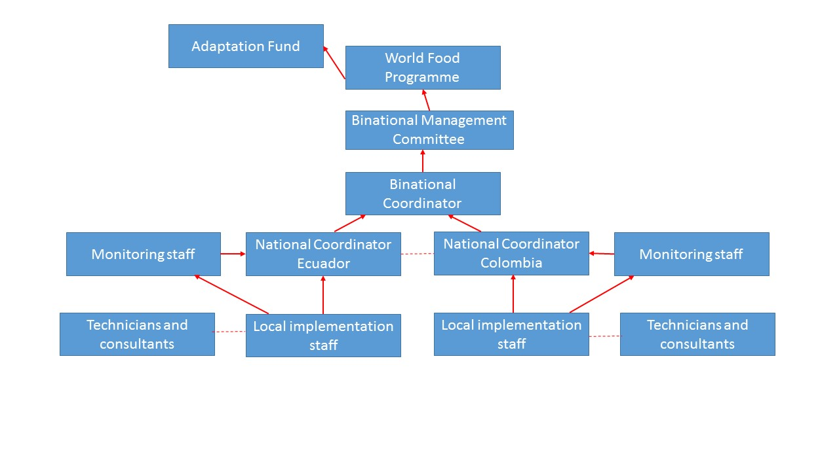
Figure 2: Monitoring and evaluation process

4.4 Procurement

On December 2017, WFP carried out a procurement assessment to identify the best purchase model to be implemented during the project. This study analyzed different purchase options, available services, logistics, local suppliers and prices, as well customs and local regulations on the Colombia-Ecuador border. The assessment concludes that WFP will carry out procurement processes independently in each country, according to national regulations.
In particular, when a procurement process is needed, the Binational Project Coordinator will inform the WFP Requesting Unit. Once informed, this Unit will proceed to set the terms of reference (specifications) and perform a preliminary screening of potential suppliers. The WFP Purchase Unit will then prepare a short list of providers, carry out a rapid assessment and submit a detailed report to the WFP Local Purchasing Committee in each country. After this phase, the WFP Local Purchasing Committee will review the submitted report, provide feedback and make recommendations on the purchases to the Delegate Procurement Authority, who finally approves the process.
The figure below outlines the procurement plan process:

Figure 3: Procurement plan process

Key Challenges

Security on the Border Area
Since 2016, the security situation in the region is worsening due to the presence of armed groups on the Colombia-Ecuador border area as well as an influx in illicit crops. Many participants of the inception workshop, as well as Afro and Awa communities leaders, highlighted the need to consider the violent events against local population due to the presence of new armed groups, in accordance to the actual security context.
Violence and insecurity have also increased in the study region, especially on the Colombian border, where threats to indigenous communities’ leaders are frequent, causing forced displacements of community members. The recent attacks are likely a demonstration of force by criminal groups and a retaliation for anti-narcotics operations on the border area.
In order to ensure security in the field WFP will follow the recommendations issued by the United Nations Department of Safety and Security (UNDSS), as well as complying with existing security regulations (MOSS). WFP will also maintain constant communication with different stakeholders as well as with the targeted communities.
Recognition of the Cultural Identities and Rights of Communities
To ensure successful implementation, the project will work directly with the communities in the targeted watersheds using community-based participatory methodologies. Community members’ cultural identity, sense of belonging, ancestral traditions and forms of social organizations will be recognized and respected. For this reason, the recovery of native species and the collection of ancestral knowledge on adaptation to climate change and food security and nutrition will be carried out.
The project will also ensure the participation of community leaders in decision-making processes at local and national levels. The project will contribute to the empowerment of these vulnerable groups on specific adaptation actions. Promotion of human rights and cultural identity will be achieved by creating awareness with actors involved in the project implementation.
Promotion of Gender Equality and Women’s Empowerment among Afro and Awa population
The project will also address gender inequalities in the Awá and Afro communities. A gender action plan will be developed and implemented to improve the living conditions of women and reduce their vulnerabilities to climate change. It is necessary to adopt appropriate strategies for women empowerment and social inclusion, with due respect to their culture, ways of life, traditions and local laws, with a special emphasis on participation in the decision-making process and on the control of their natural resources.
The project’s gender strategy will be based on communities’ local needs, recognizing that men and women have different roles and responsibilities and often have different needs, capacities, vulnerabilities and risks perceptions. Gender roles and needs will be identified by a gender assessment in targeted communities through appropriate methodologies to the Awá and Afro contexts in the two watersheds. The project will also monitor compliance alongside the findings of the gender assessment, throughout project implementation. Annex 7 presents guidelines for gender mainstreaming, designed by WFP as the initial step of the gender action plan.
Changes in Colombian Government
At the end of May 2018, Colombia will undergo presidential elections, which will introduce changes in the government structure, specifically at the ministerial level, including the (MADS). These changes will take place in August 2018, and could affect the project timeline. The Binational Management Committee, and the Binational and National Coordinators will assess any change in governments or mandates. These challenges can be minimized through coordination among stakeholders at national level, as well as at the departmental and local levels (Grand Family Awá, RECOMPAS, CANE and community councils).

General conclusions

The elaboration of adaptation plans and the identification of concrete adaptive measures will be developed according to the local context, taking into account local ecosystems, social and cultural contexts as well as the underlying gender roles in Awá and Afro communities.
Participation by the Afro and Awa community members in decision-making processes will be ensured at all levels.
In order to ensure that local communities are well informed about the projects scope, goals, and objectives and to promote the involvement of communities’ members in climate change territorial planning, project stakeholders will suggest holding national meetings within the target communities. The proposed meetings will be held at the end of June and early July 2018.
Activities will be coordinated with regional and local institutions, such as GADS, Regional Environmental Authorities, Research Institutions, NGOs as well as other organizations who are working in the target communities.

Annexes

CAF. 2014. Vulnerability Index to climate change in the Latin American and Caribbean Region
Seddon, A.W.R., et al. 2016. Sensitivity of global terrestrial ecosystems to climate variability. Nature.

